**DELIVERABLE 10 ITEM 5: PERFORMANCE REPORT**

The aim of this report is to show the information related to our project performance attained through the performance tests that our group has carried out. These tests have been run in different machines, and therefore, we will indicate the properties of each machine used to run the tests. Our first tests have been made with 30 concurrent users and 100 loops. Afterwards, we have determined which are the use cases that stress our system the most and we tested them again in order to determine which is the maximum system workload.

**TESTS RAN IN MACHINE 1**

This computer has the following features:

Processor: Intel(R) Core(TM) i7-7700HQ CPU @2.80GHz 2.81GHz

RAM memory: 12GB

Hard Disk: 765GB HDD

Wireless adapter: Intel (R) Dual Band Wireless-AC 7260.

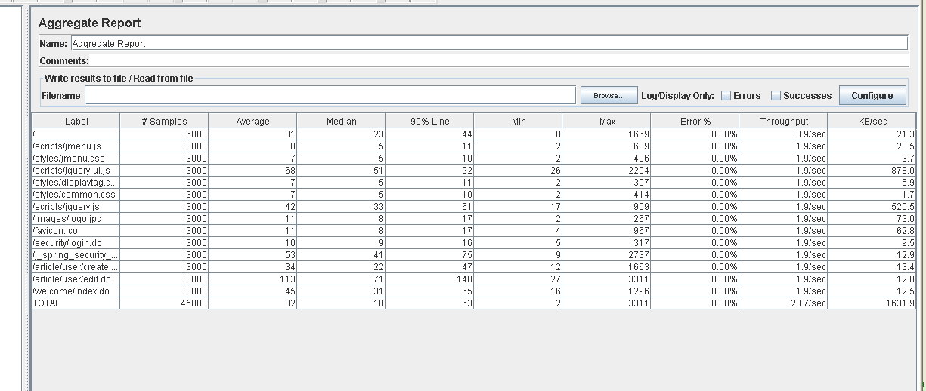Test 1: Create a new article

Test 2: Create a new followup

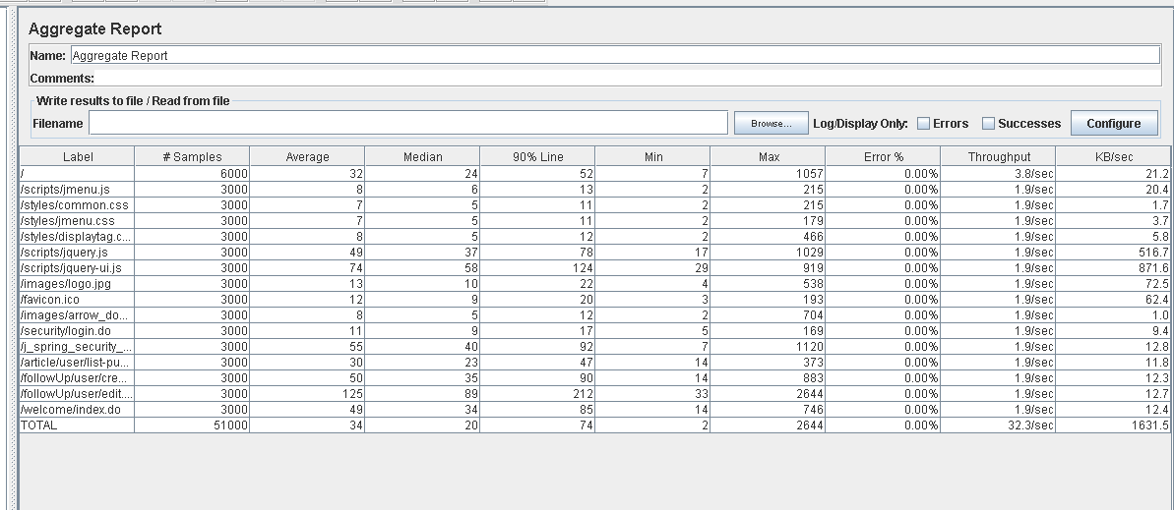

Test 3: Delete an article

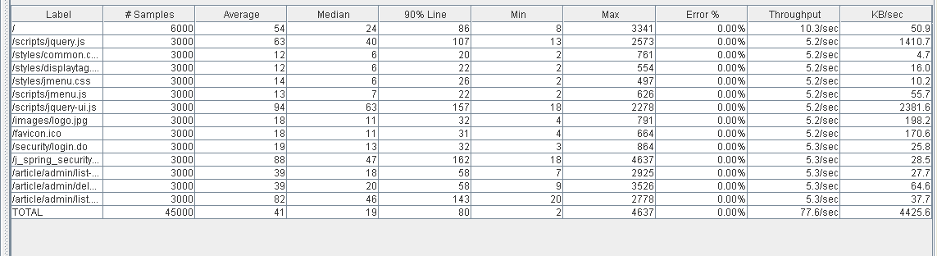

Test 4: Delete a followup

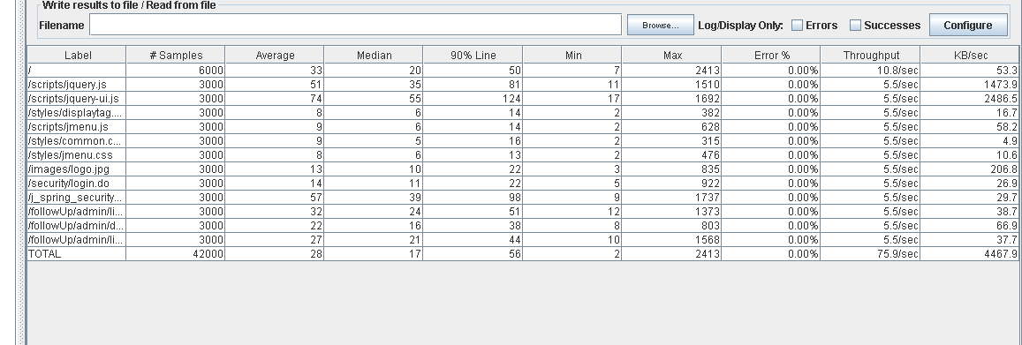

Test 5: Access to articles belonging to a private newspaper as a customer.

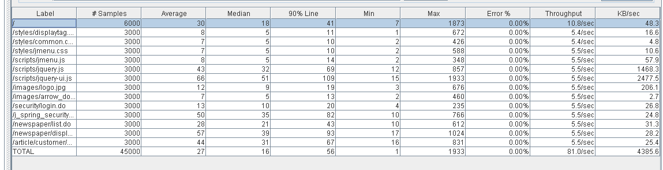

Test 6: Search an article by keyword.

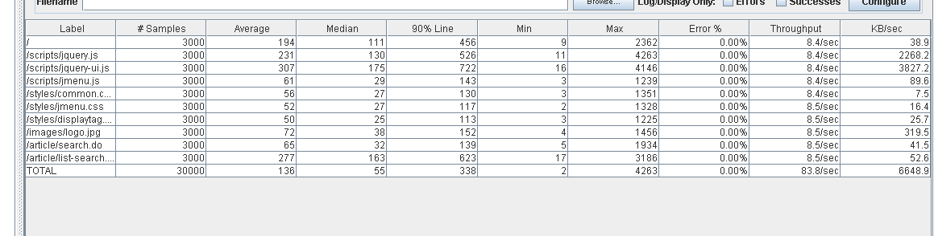

Test 7: Display a followup.

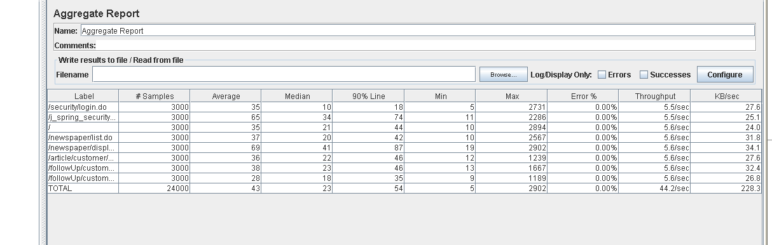

Out of all the tests ran in this machine, searching an article by keyword is the one that takes more time. This will be one of the tests we will analyze more in-depth afterwards.

**TESTS RAN IN MACHINE 2**

This computer has the following features:

Processor: Intel(R)Core(TM) i5-7200U 2.5GHz with Turbo Boost up to 3.1GHz

RAM memory: 8GB DDR4

Hard Disk: 1000 GB HDD

Wireless adapter: Intel(R) Dual Band Wireless-AC 3168.

Test 8: Admin Dashboard

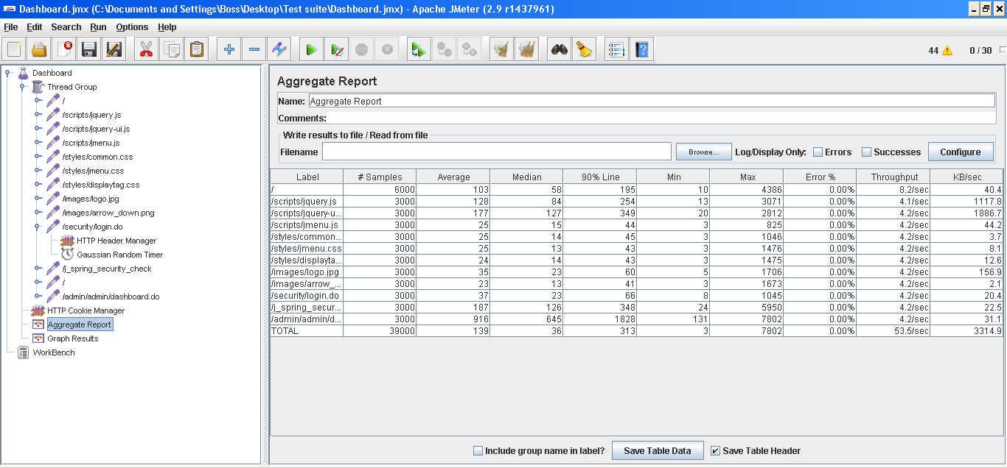

Test 9: List followed users

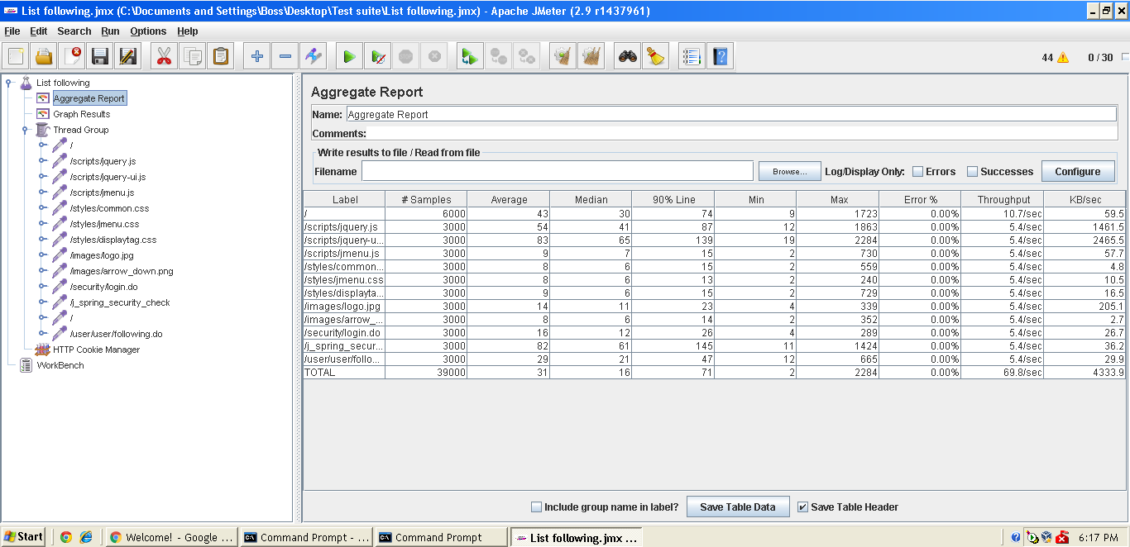

Test 10: List followers.

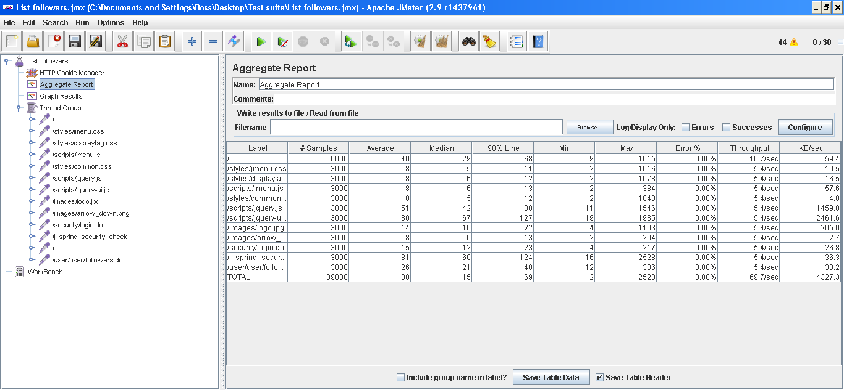

Test 11: List all users.

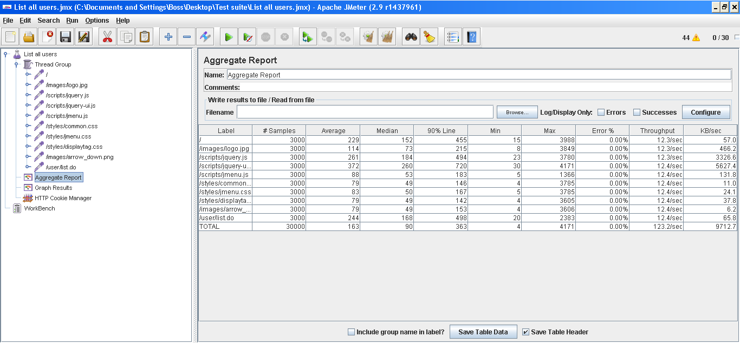

Test 12: Register to the system.

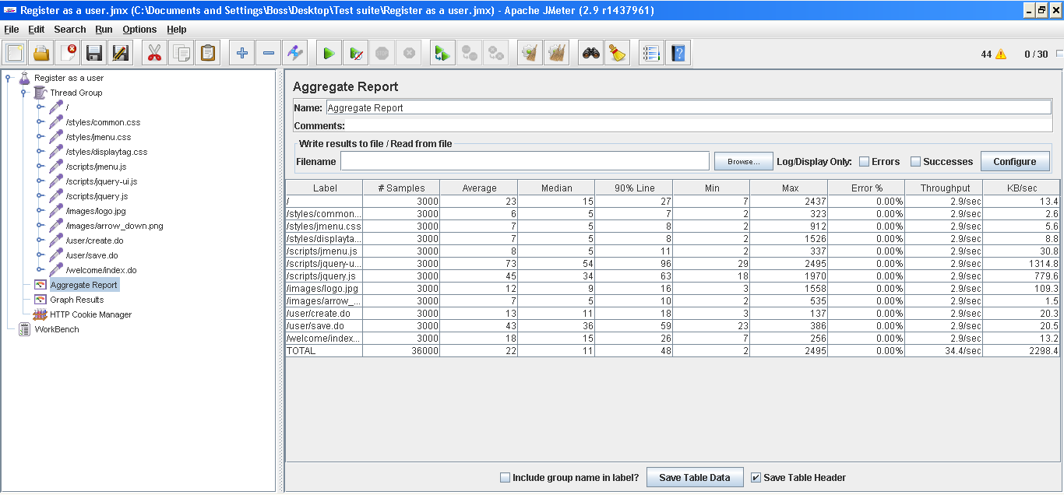

Test 13: Unfollow and follow a user.

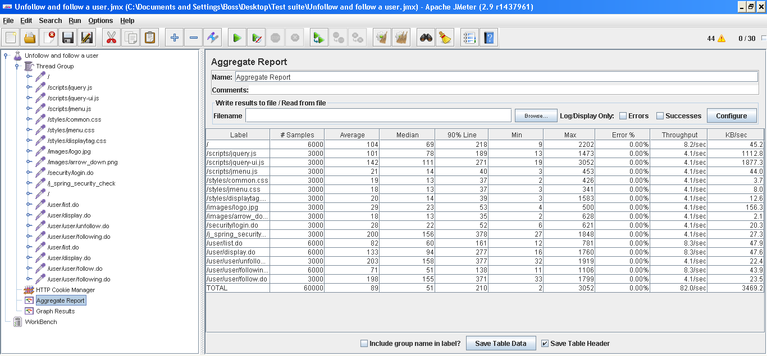

We can see that the administrator dashboard and the listing of all users are the ones that stress our system the most. However, because the administrator dashboard use case is only admin related, it does not make much sense to take it into account when trying to analyze the maximum workload of our system, because there will never that many concurrent administrators. We will further analyze the listing of all users.

**TESTS RAN IN MACHINE 3**

This computer has the following features:

Processor: Intel Core i7-6500U (2-core,2.50-3.10 GHz, 4MB cache)

RAM memory: 8GB DDR3.

Hard Disk: 1000 GB HDD.

Wireless adapter: Qualcomm Atheros QCA61x4A Wireless Network Adapter.

Test 14: List published newspaper and display their articles.

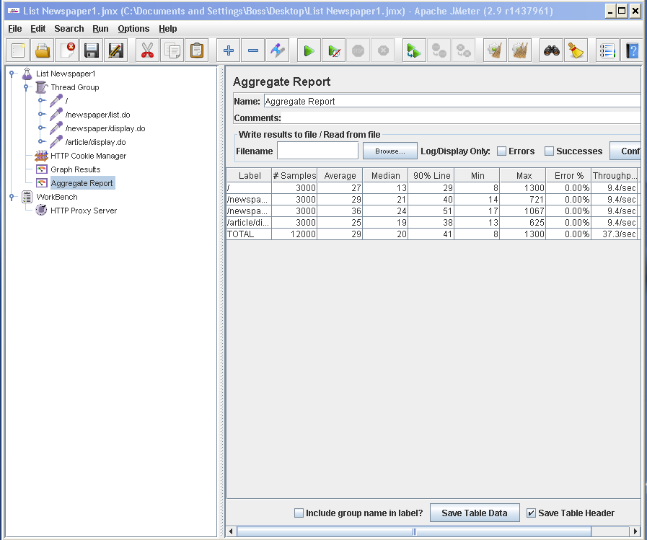

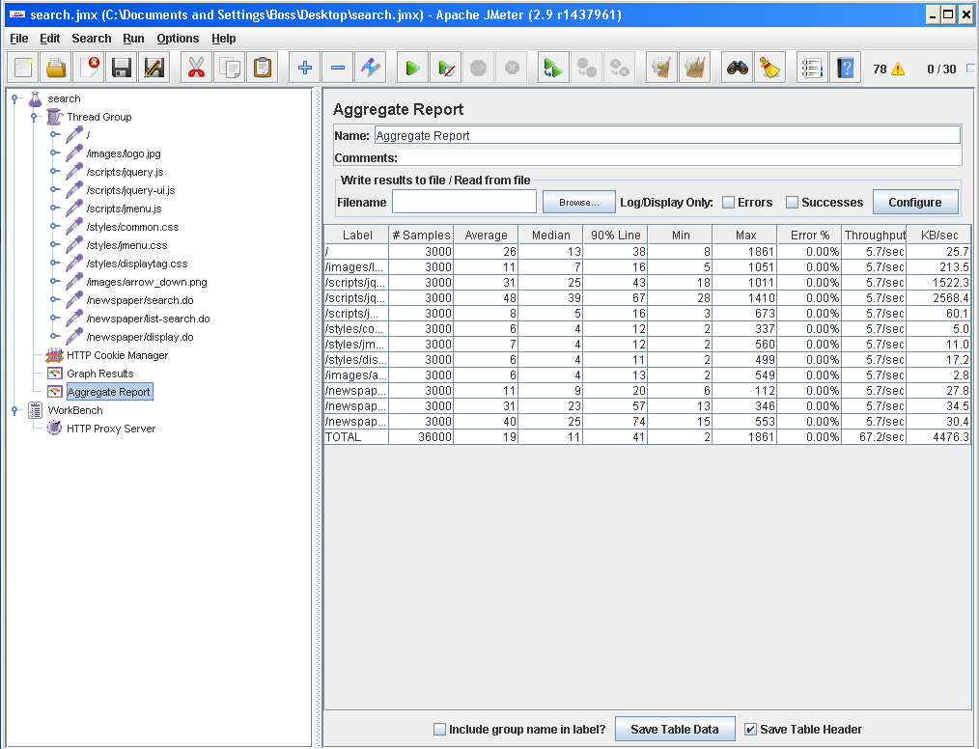Test 15: Search newspapers by keyword.

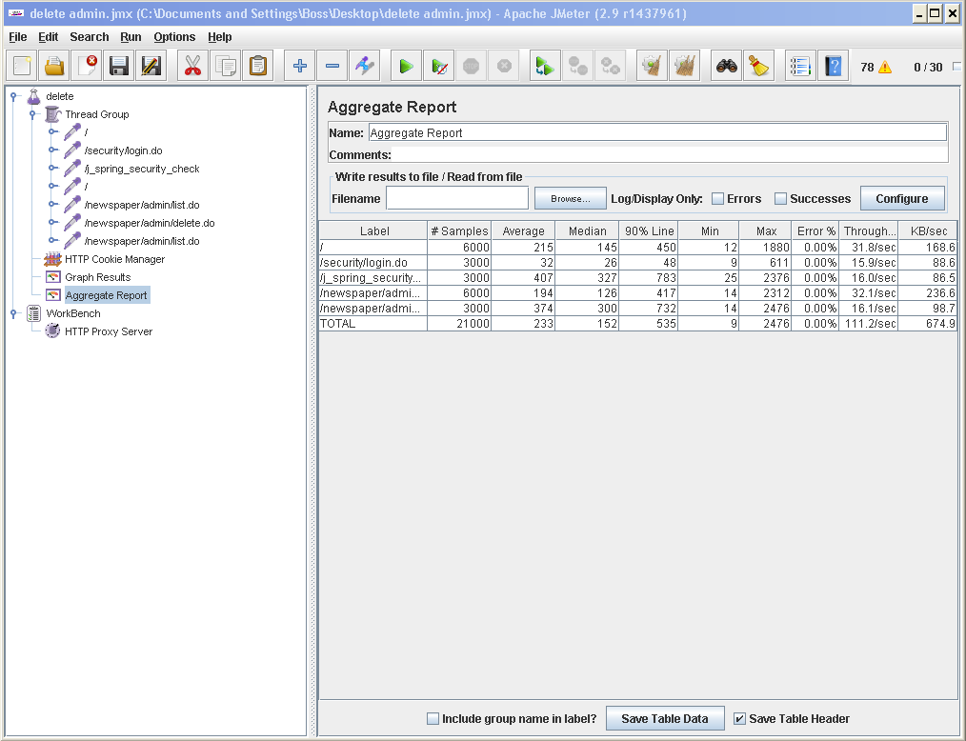Test 16: Delete a newspaper.

Test 17: List marked newspapers.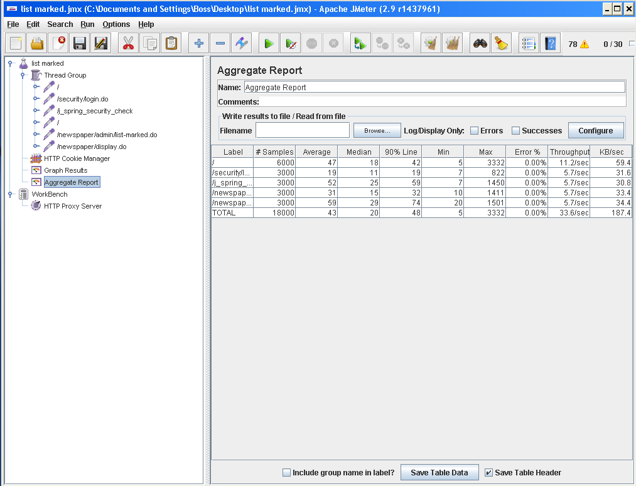

Test 18: Suscription to a newspaper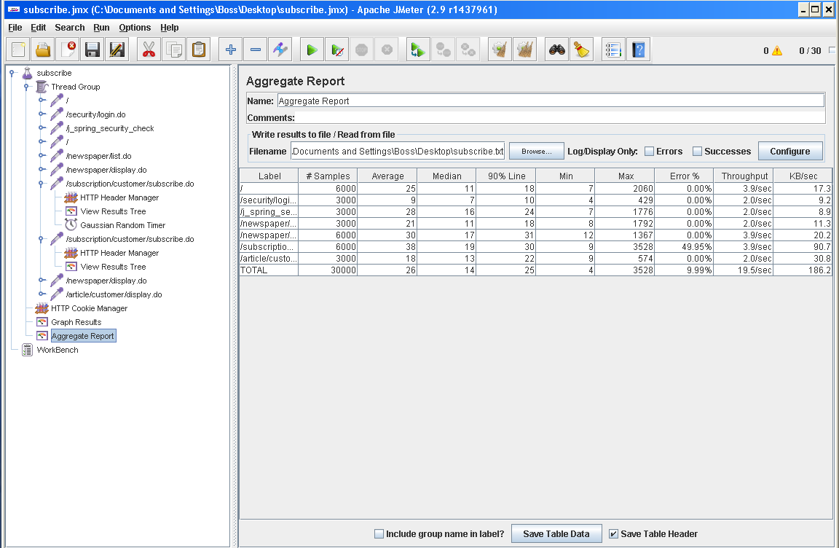

There are errors in this test. The reason why this happens is because we are always using the same customer and the same newspaper, and because an user can’t subscribe to a newspaper he is already subscripted to, the following error appears:

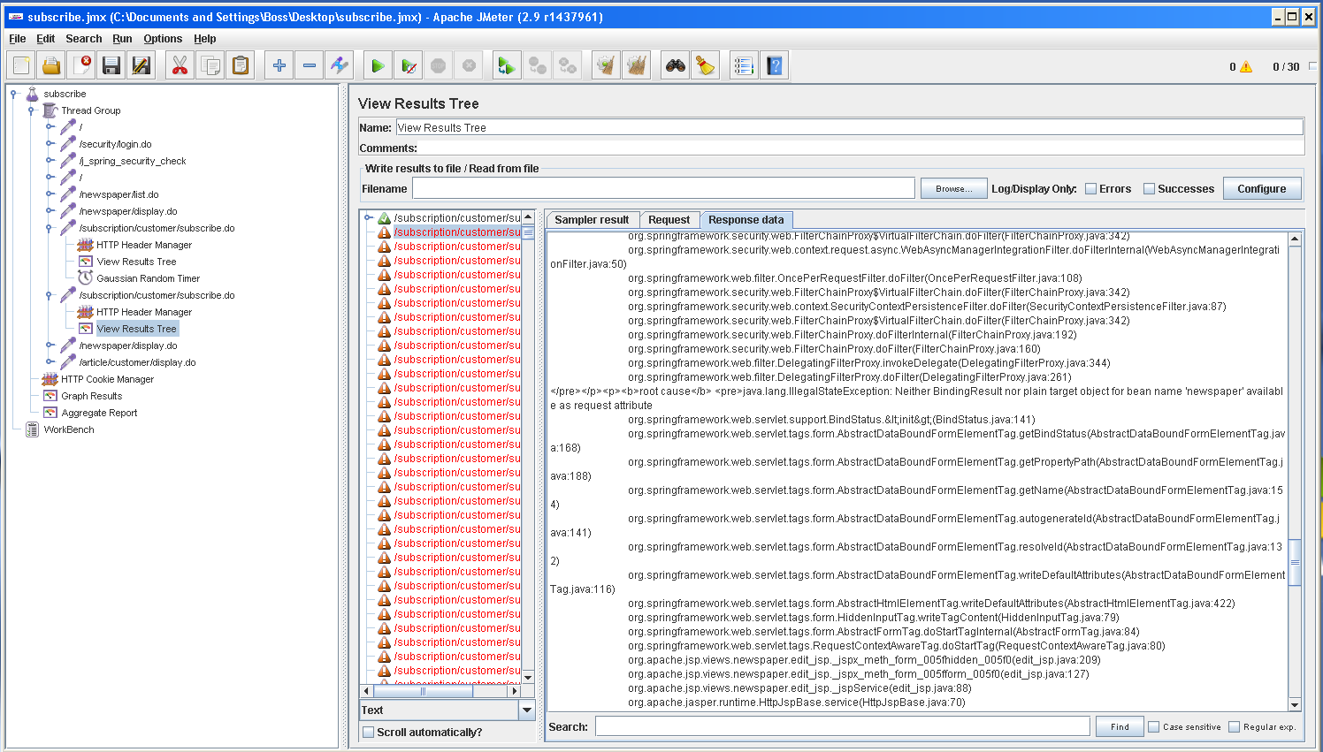

Test 19: Creation of a newspaper

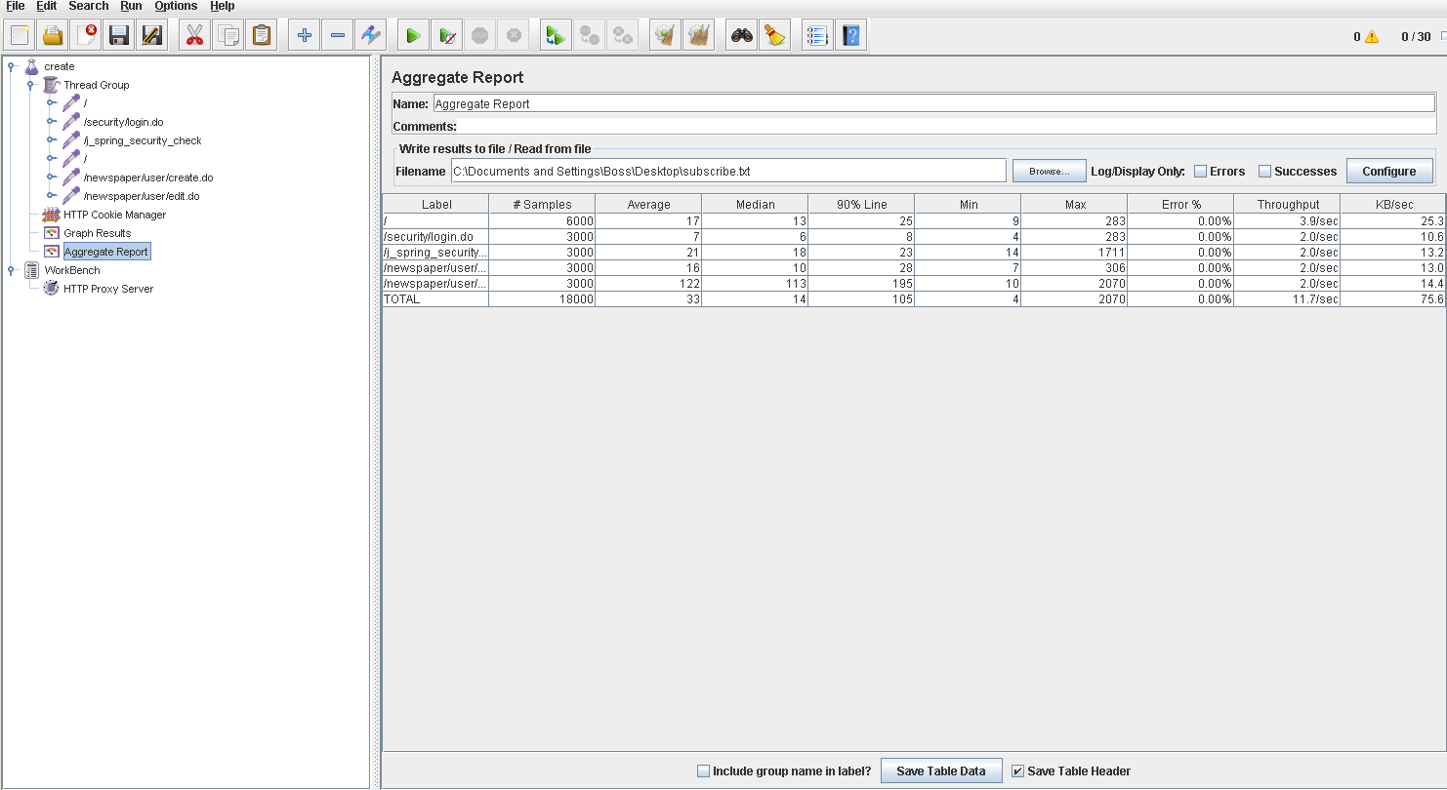

Test 20: Publishing a newspaper.

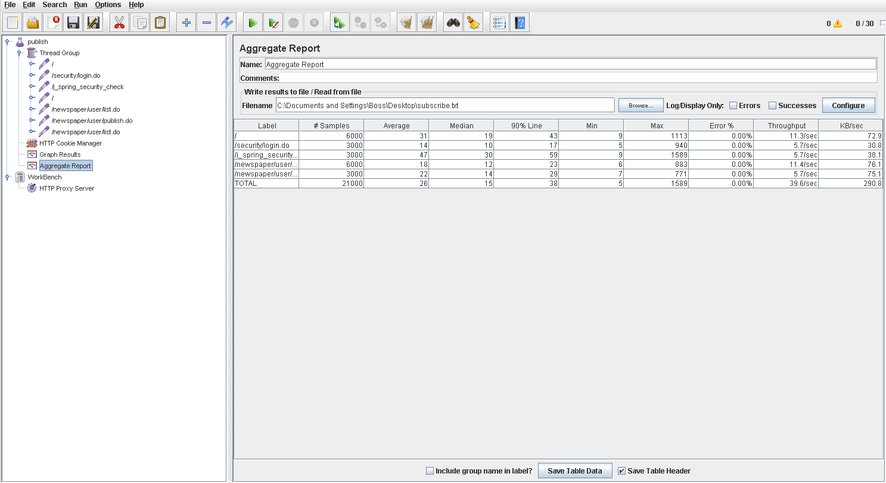

Out of all the tests ran in this machine, deleting a newspaper is the one that takes more time. This will be one of the tests we will analyze more in-depth afterwards.

**TESTS RAN IN MACHINE 4**

This computer has the following features:

Processor: Intel Core i5-7300HQ (2,5 GHz-3,5 GHz, 6 MB cache, 4 cores)

RAM memory: SDRAM 8 GB DDR4-2400 (1 x 8 GB)

Hard Disk: SATA 1 TB 7200 rpm

Wireless adapter: Intel(R) Dual Band Wireless-AC 7265

Test 21: Creating a chirp.

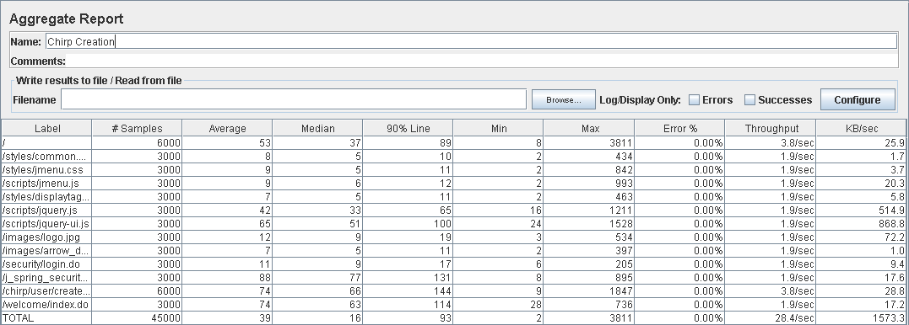

Test 22: Deleting a chirp.

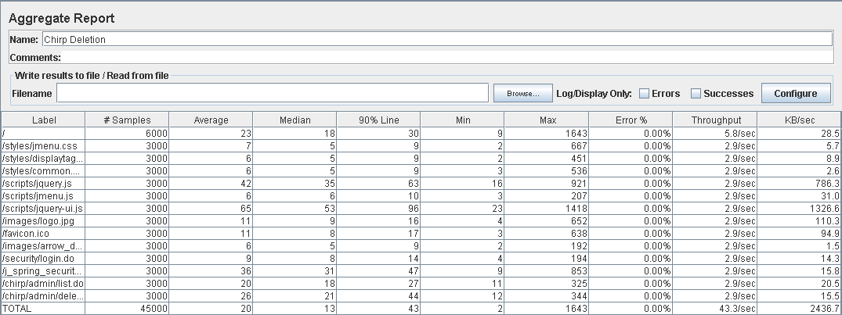

Test 23: Creating a customer

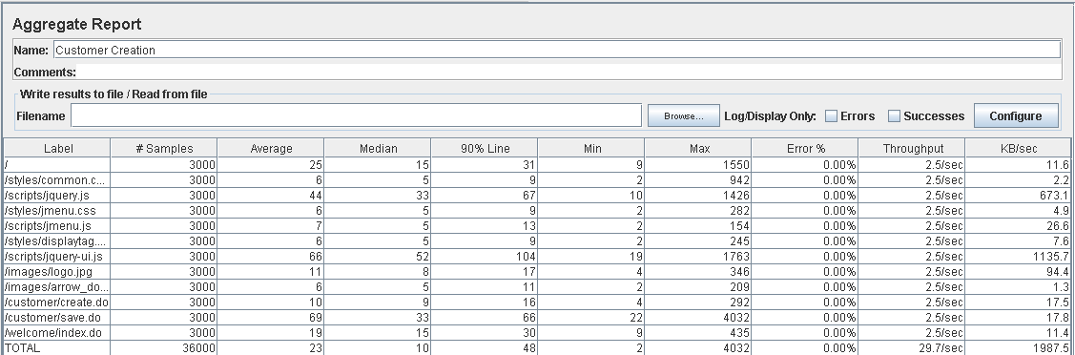

Test 24: List chirps of followed users.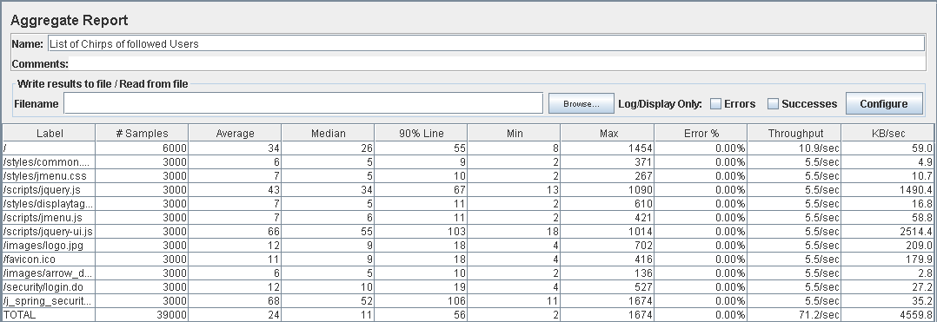

Test 25: List of marked chirps.

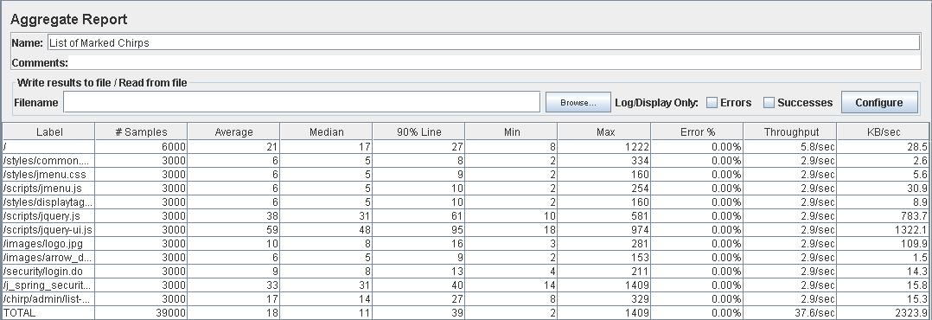

Test 26: Taboo word creation.

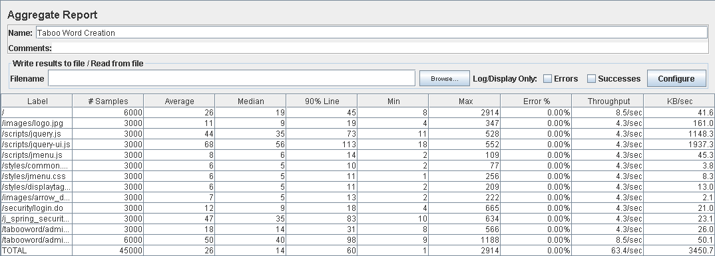

Test 27: Taboo word deletion

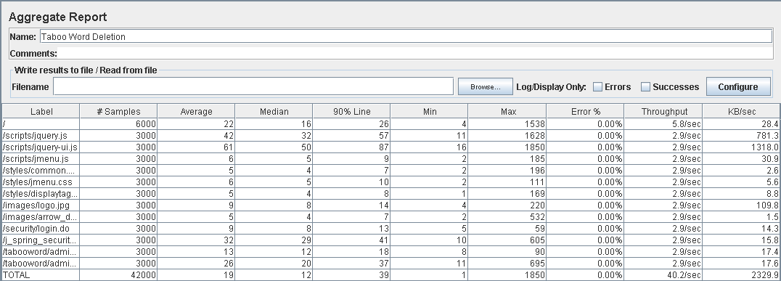

Test 28: Lists of taboo words.

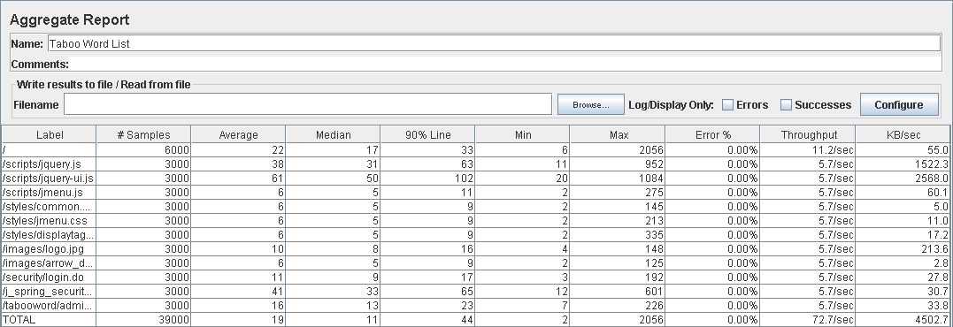

Out of all the tests ran in this machine, creating a chirp is the one that takes more time. This will be one of the tests we will analyze more in-depth afterwards.

**TESTING THE MAXIMUM PERFORMANCE OF THE SYSTEM**

We will test again the following tests, this time all of them in the machine 1:

* Search article by keyword
* List all users
* Create a chirp
* Deleting a newspaper

In order to simulate a more realistic scenario, we will run these tests with ~100 articles and ~100 newspapers already loaded in our database. Firstly, we will run the tests again with 30 concurrent users and see if the increase on the amount of data that our system contains mean that 30 concurrent users is already the maximum our system endure. If the results we get after running these tests are still acceptable, we will run them again increasing the number of concurrent users.

Test 29: Search article by keyword(II) 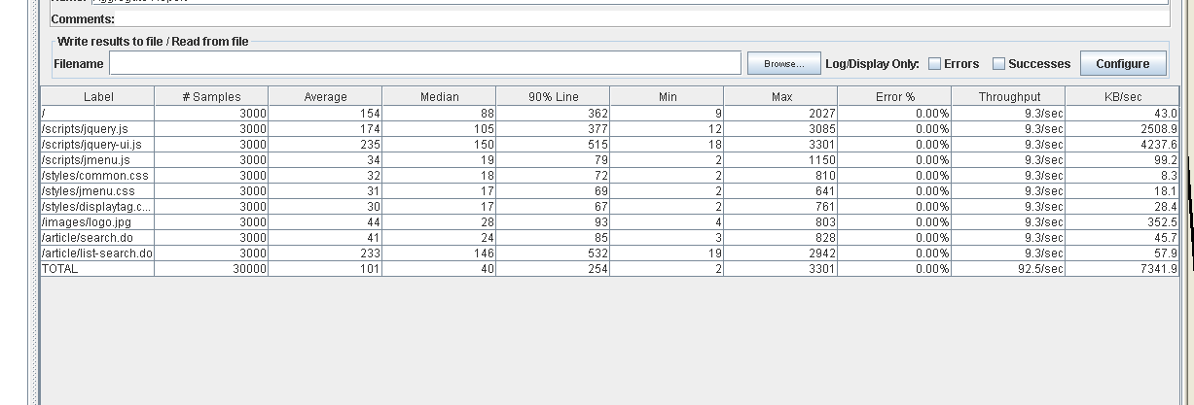

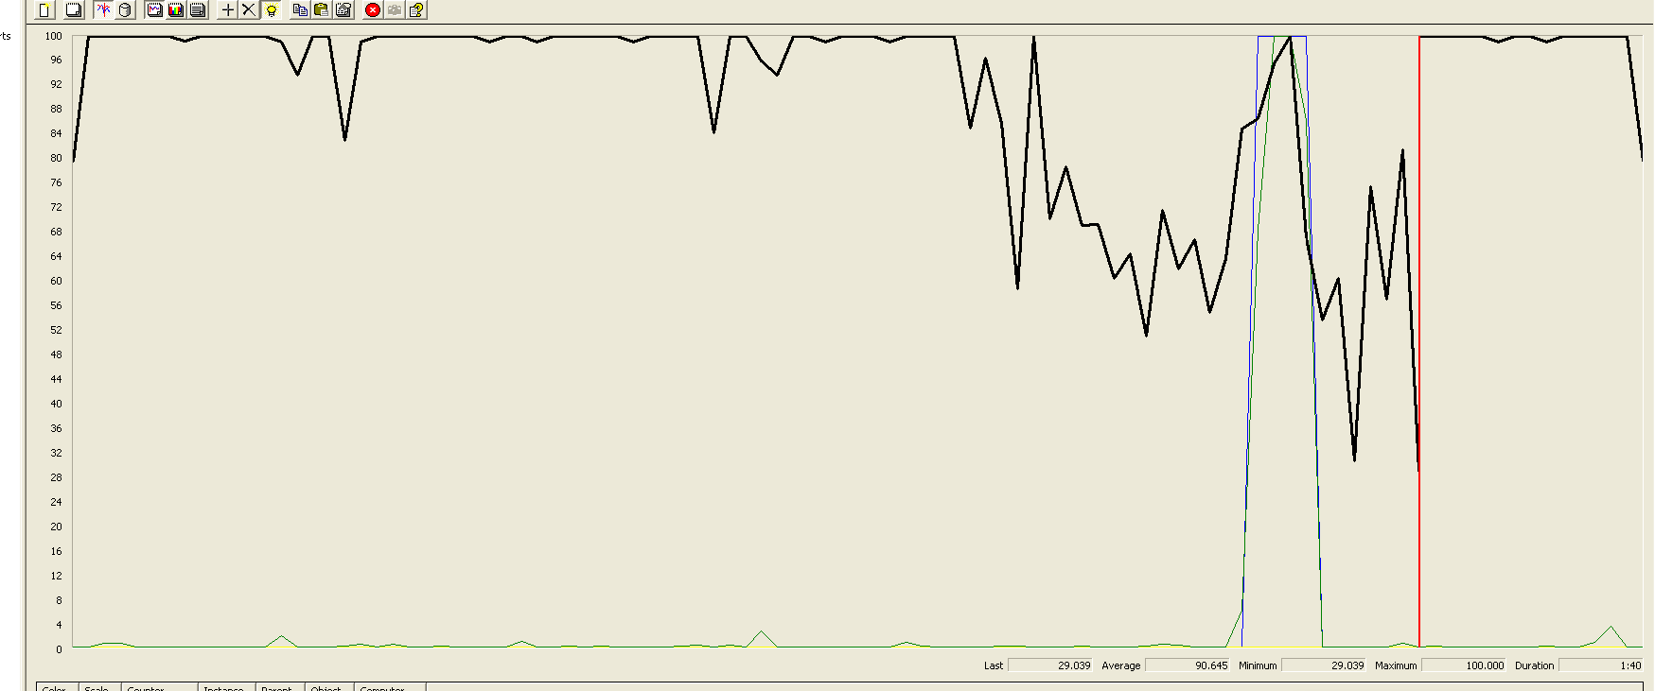

Test 30: List all users(II)

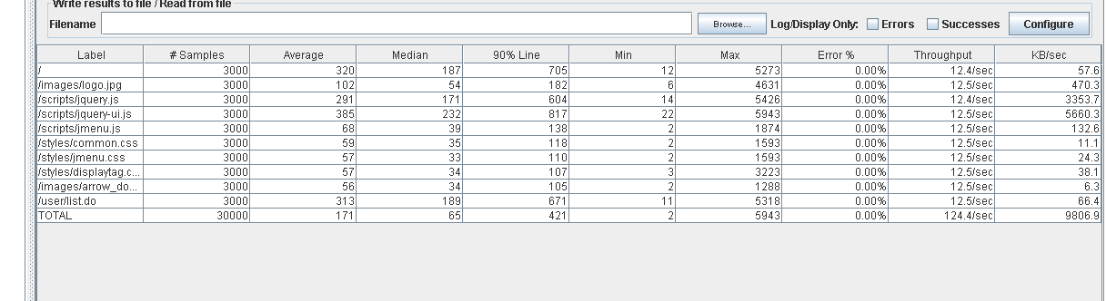

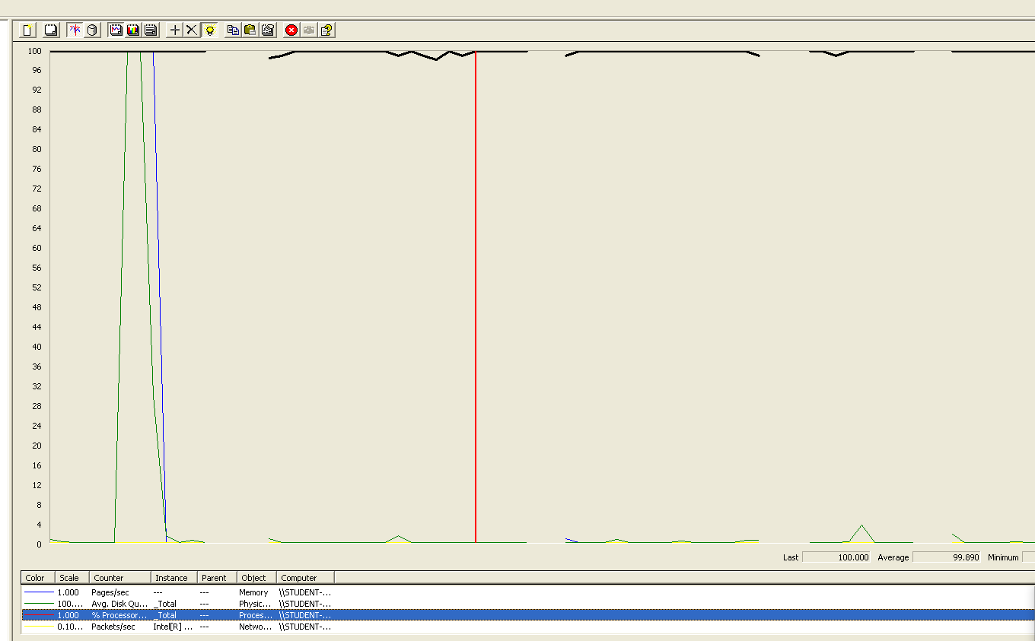

Test 31: Create a chirp(II)

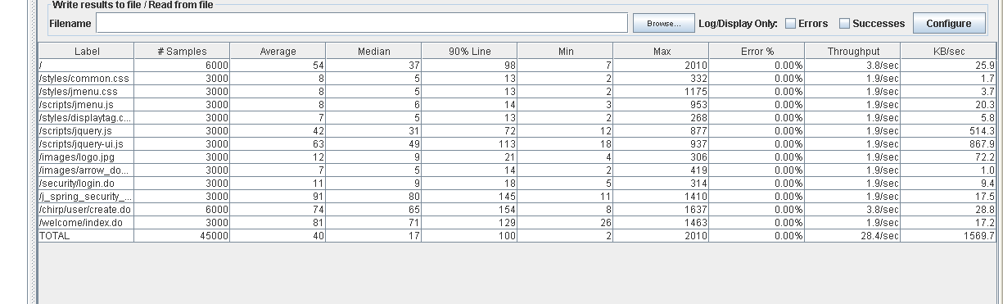

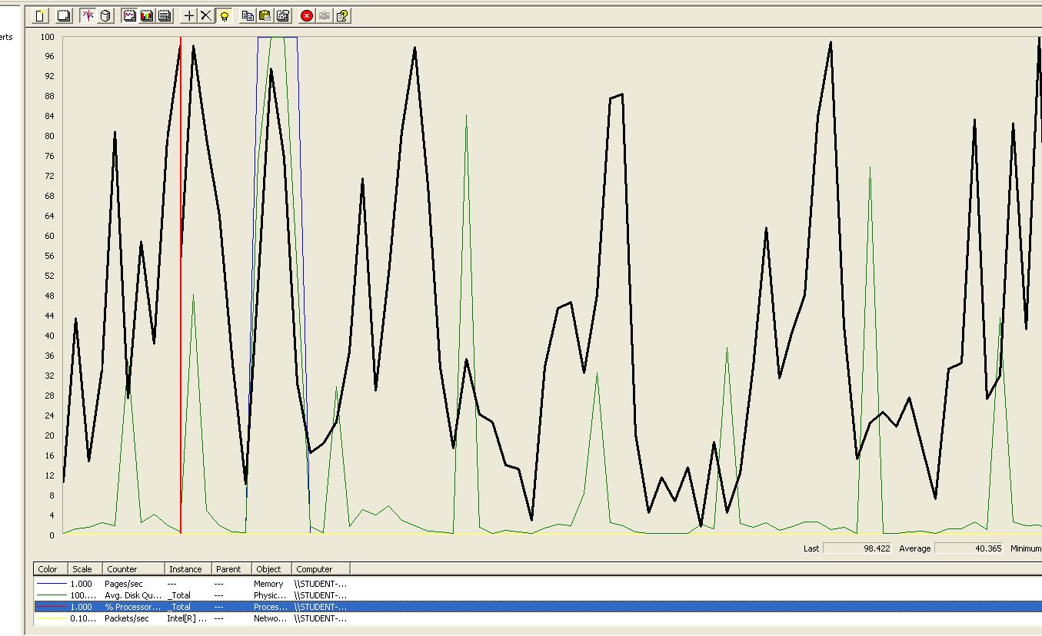

Test 32: Deleting a newspaper(II)

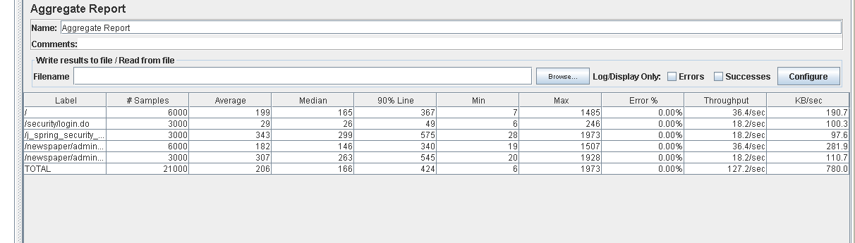

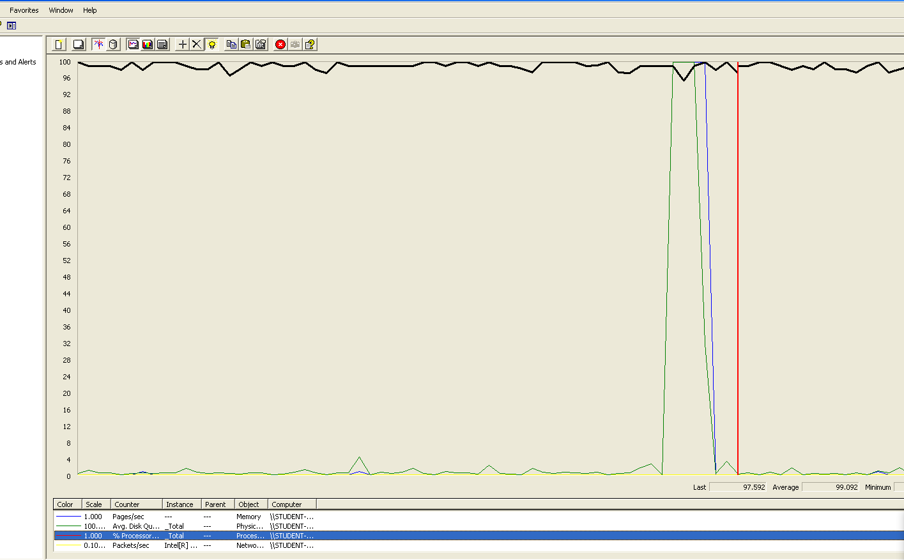

With this data, we can conclude that our system can deal with more concurrent users than 30. We also noticed that the processor is the component that is under the biggest stress, and therefore, will eventually become a bottleneck.

Next, we will repeat these tests with 60 concurrent users, but this time we will not test the creation of chirps, because there is a noticeable difference between the time it takes to create a chirp compared to the 3 other use cases. That means it is not going to be very useful when trying to determine the maximum performance of the system.

Test 33: Search article by keyword(III)

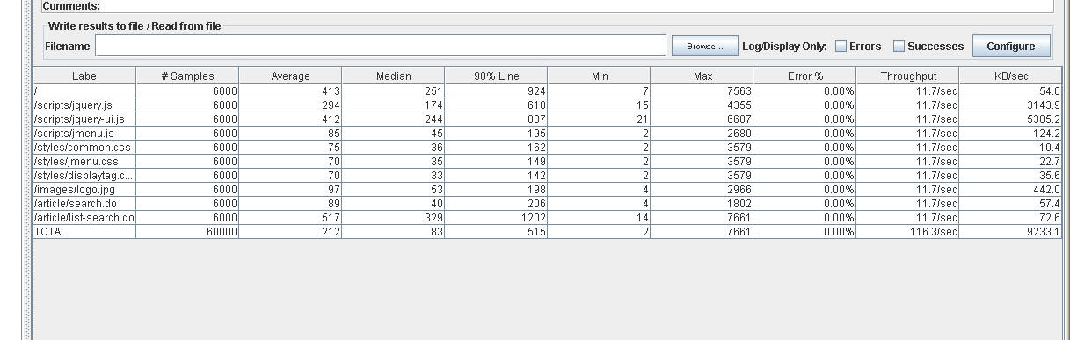

Test 34: List all users(III)

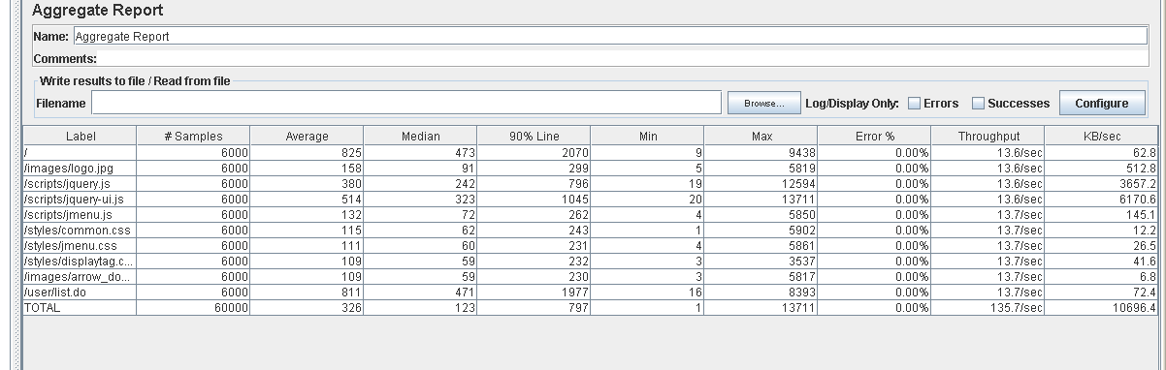

Test 35 Deleting a newspaper (III)

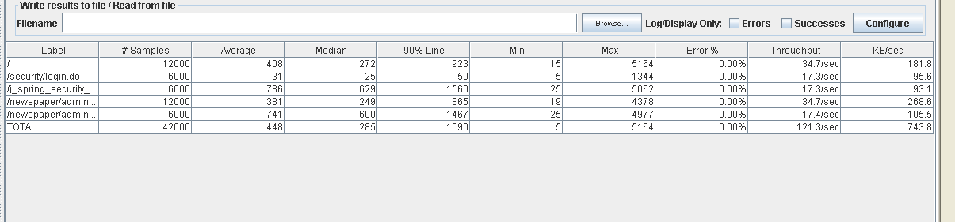

At this point, there is a slight delay of 1-2 seconds in some actions. This delay starts to become noticeable but is still manageable. Finally, we will rerun the test associated with the listing of all the users, which is the slowest one, with 100 concurrent users and see how it affects to our system.

Test 36: List all users(IV)

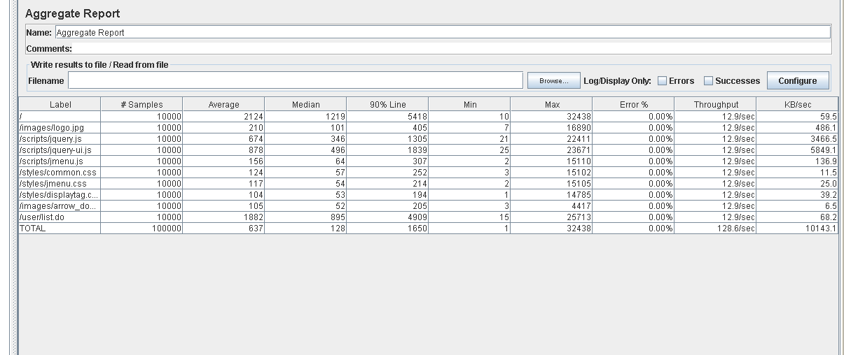

**FINAL CONCLUSIONS**

We can conclude that our system can deal with 60 concurrent users at an acceptable level. When facing around 100 users, there are usually delays of nearly 5 seconds, which is something noticeable but still acceptable, but we must also take into account that our database only has a small data sample compared to the one our system may end up having in a realistic scenario, so these delays will end up being much bigger. Therefore, 100 concurrent users is the limit that we set for the maximum workload our system can handle. We have also reached the conclusion that should one use case start to suffer from too many stress, the listing of all users is the most likely to suffer it first (excluding administrator related actions). We have also noticed that in this case, the processor will the physical component that acts as a bottleneck.